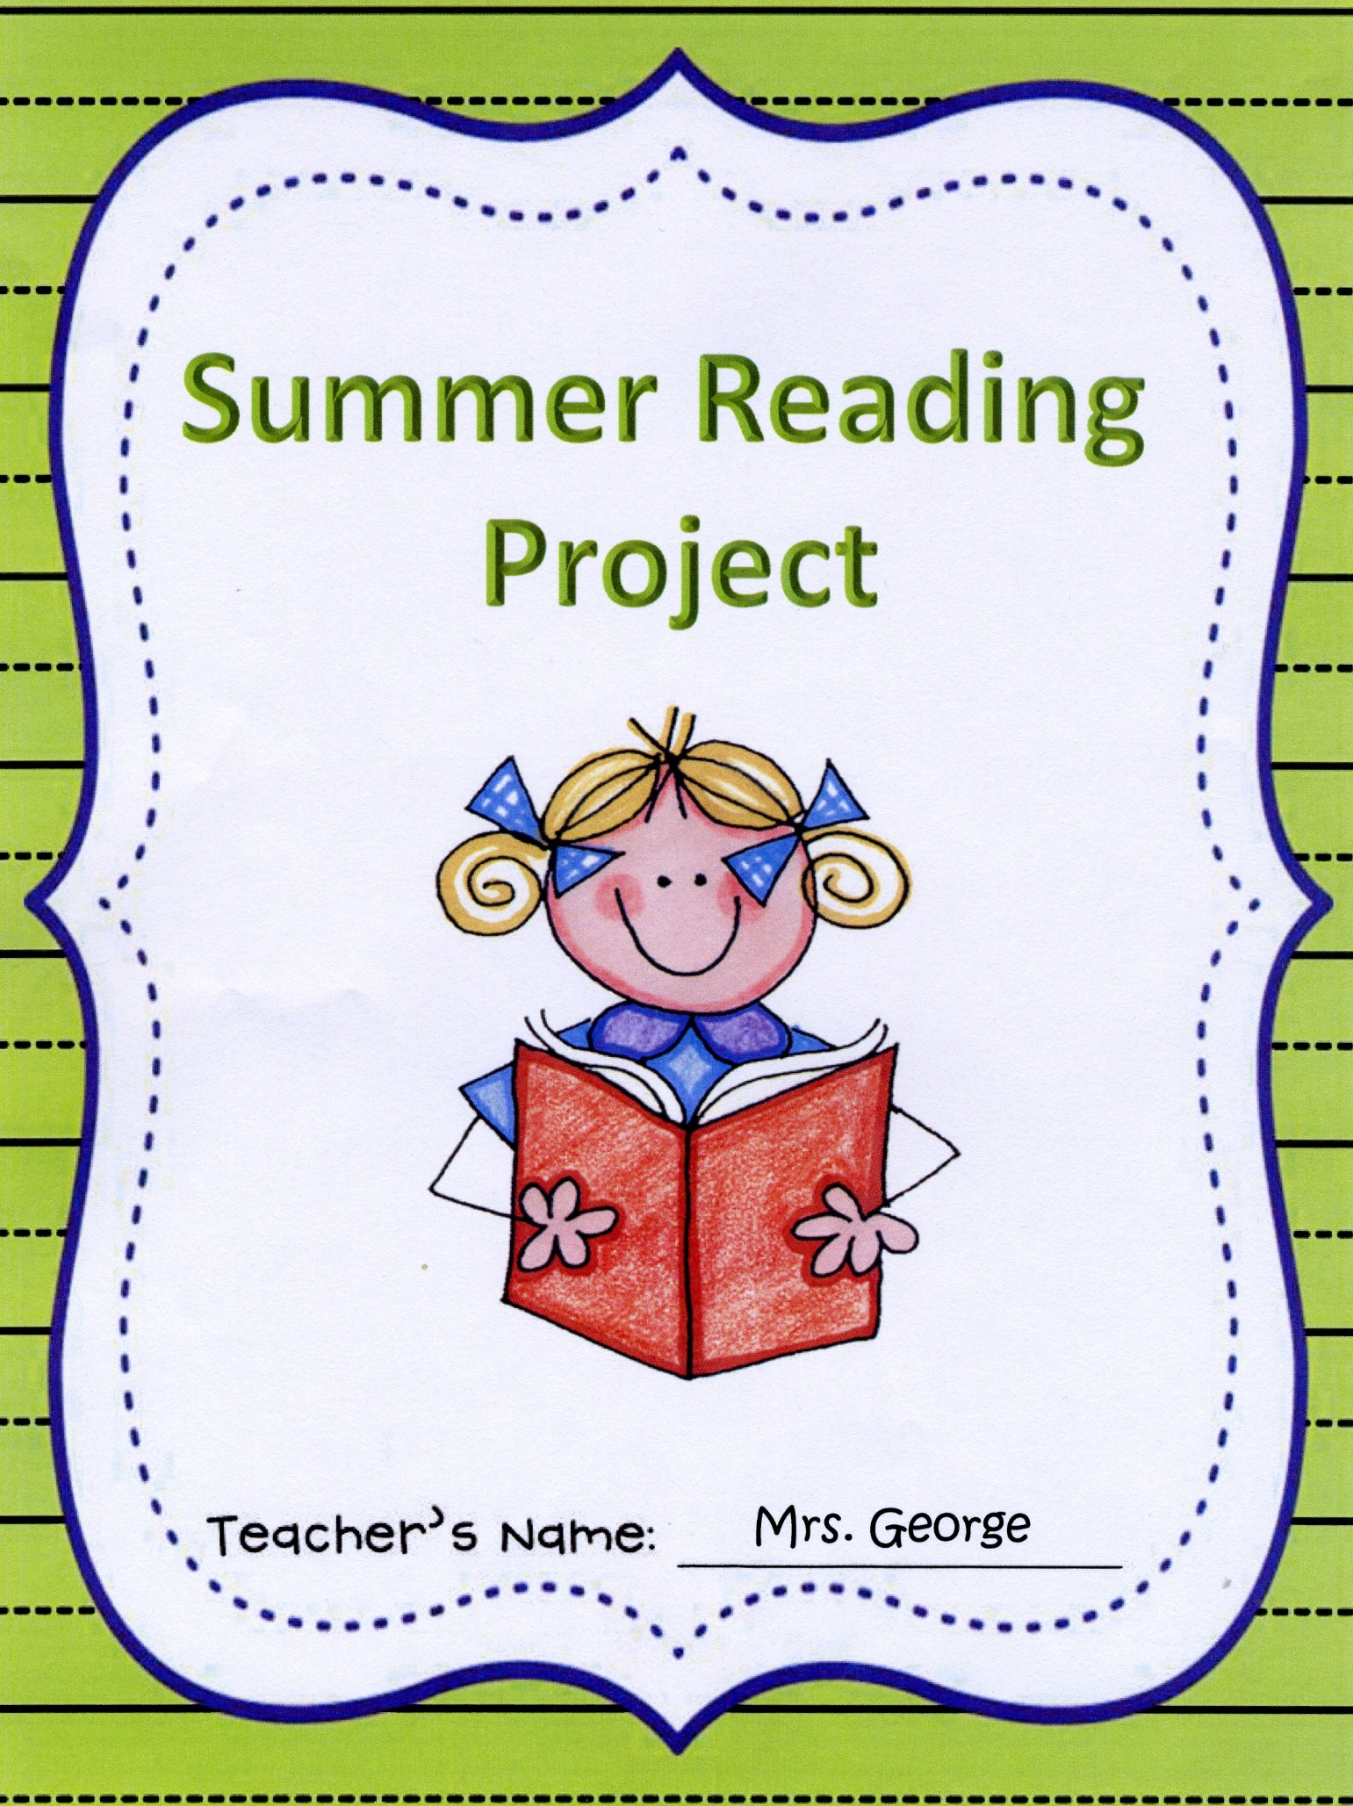

Summer Reading Assignment for Third Grade

Summer is here! You have worked so hard in second grade to become a strong reader, so it is important that you keep reading throughout the summer so you can continue your success in third grade.
As part of your summer vacation plan, you must continue to find time each day for reading. You will keep a calendar log of your reading, answer a journal entry for each book, and complete a summer reading project for one of your books.

Assignment:
- READ!!!!!
  - Read at least 3 days a week.
  - Read for at least 10-15 minutes.
  - Read at least 4 books at your AR reading level
  - Read at least 1 non-fiction book
  - Read chapter books at your AR reading level

- WRITE!!
  - Log your reading onto your reading calendars. The boxes should be filled out with title and time read to get full credit. A parent must initial each entry.
  - Complete one of the response journals after each chapter book.
    - Parents, please help your child complete this entry to the best of their ability. Each page has a place for your child to write the title and author of the book to which they are writing a response.

All journal entries must be in complete sentences and include text evidence from the story. Writing must be neat!

- PICK!!!
  - Pick one of the following projects to do on one of the chapter books you read:
- Write a new ending – This new ending should be at least one page in length.
- Make a 3 minute video recording – Reenact one of your favorite events from the story. You can use friends and family to help be the characters. Copy the video onto a DVD to bring to school.
- Make a shadow box or diorama – This will display your favorite scene from the book.
- Write a comic book – This should tell about your favorite parts of the story. It should have at least 6 scenes or sections. Include illustrations in either black and white or color and also dialogue bubbles.
Create your own comic strip or book online at: http://www.makebeliefscomix.com/Comix/ or
http://bitstrips.com/pageone/ or
http://www.pixton.com/

Assignment Support:
Wondering whether your book is an AR book?
Go to: http://www.arbookfind.com/UserType.aspx

Your end of second grade AR Level _____________________________

Sunday | Monday | Tuesday | Wednesday | Thursday | Friday | Saturday
1 | 2 | 3 | 4 | 5 | 6 | 7
8 | 9 | 10 | 11 | 12 | 13 | 14
15 | 16 | 17 | 18 | 19 | 20 | 21
22 | 23 | 24 | 25 | 26 | 27 | 28
29 | 30
June 2014

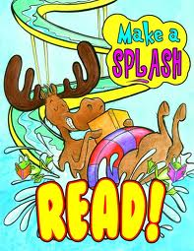
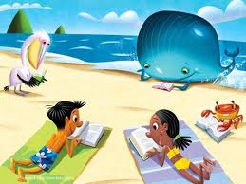
July 2014
Sunday | Monday | Tuesday | Wednesday | Thursday | Friday | Saturday
 |  | 1 | 2 | 3 | 4 | 5
6 | 7 | 8 | 9 | 10 | 11 | 12
13 | 14 | 15 | 16 | 17 | 18 | 19
20 | 21 | 22 | 23 | 24 | 25 | 26
27 | 28 | 29 | 30 | 31

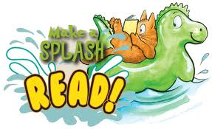
August 2014
Sunday | Monday | Tuesday | Wednesday | Thursday | Friday | Saturday
 |  |  |  |  | 1 | 2
3 | 4 | 5 | 6 | 7 | 8 | 9
10 | 11 | 12 | 13 | 14 | 15 | 16
17 | 18 | 19 | 20 | 21 | 22 | 23
24  31  31 | 25 | 26 | 27 | 28 | 29 | 30

Journal entry #1
Title: _________________________________
Author: ______________________________
I started reading this book on _______________
date
and finished on ___________________.
date
Choose a character from the book. What character trait(s) describe this character? Why? Give evidence from the story to support your answer.
________________________________________________________________________________________________________________________________________________________________________________________________________________________________________________________________________________________________________________________________________________________________________________________________________________________________________________________________________________________________________________________________________________________________________________________________________________________
Journal entry #2
Title: _________________________________
Author: ______________________________
I started reading this book on _______________
date
and finished on ___________________.
date
*Fiction* Write a summary of the book. Be sure to include the characters, setting, beginning, middle and end.
________________________________________________________________________________________________________________________________________________________________________________________________________________________________________________________________________________________________________________________________________________________________________________________________________________________________________________________________________________________________________________________________________________________________________________________________________________________
Journal entry #3
Title: _________________________________
Author: ______________________________
I started reading this book on _______________
date
and finished on ___________________.
date
Explain how this book reminds you of something that happened to you OR another book you read. Give text evidence from the book to support your answer.
________________________________________________________________________________________________________________________________________________________________________________________________________________________________________________________________________________________________________________________________________________________________________________________________________________________________________________________________________________________________________________________________________________________________________________________________________________________
Journal entry #4
Title: _________________________________
Author: ______________________________
I started reading this book on _______________
date
and finished on ___________________.
date
*Non-Fiction* What is the main idea of the book? Give 3 supporting details from the text.
__________________________________________________________________________________________________________________________________________________________________________________________________________________________________________________________________________________________________________________________________________________________________________________________________________________________________________________________________________________________________________________________________________________________________________________________________________________________________________________________________________
Summer Reading Project Checklist:
Did you…
READ at least 3 days a week?
READ at least 10-15 minutes each time?
READ at least 4 AR books on your level?
READ at least 1 non-fiction book?
READ chapter books at your AR level?
WRITE on your reading calendars?
GET a parent signature on each log entry?
WRITE 4 journal entries with complete and thoughtful sentences?
PICK a project and complete it?

CONGRATULATIONS!!!!
If you have checked every box, then you have avoided SUMMER BRAIN! You should feel PROUD!

This COMPLETED Summer Reading Project is due to your third grade teacher on the first day of school!

